ChÂteau de Nages - Heritage – Red – 2021

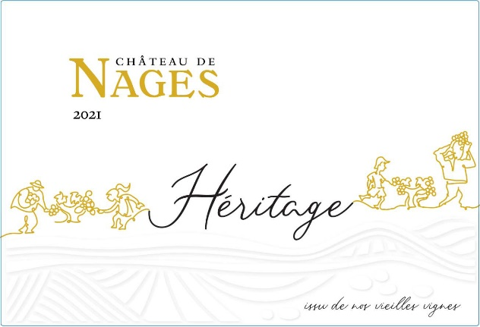
This magical terroir gives naturally exuberant wines. Our family works this land to privilege its wines’ freshness and balance. Its Rhone signature recalls the most prestigious appellations in the southern part of our beautiful valley.

Still under cap, this year's reds display beautiful dark and intense colors, and very fresh fruit with a lot of finesse. Mastery of blending and aging will be decisive in expressing the quintessence of a vintage which I believe will be greatly appreciated for its accessibility, its moderate levels of alcohol, and its lovely freshness.

Terroir: « Grès », rolled pebbles from the Rhône over iron-rich red clay rich.
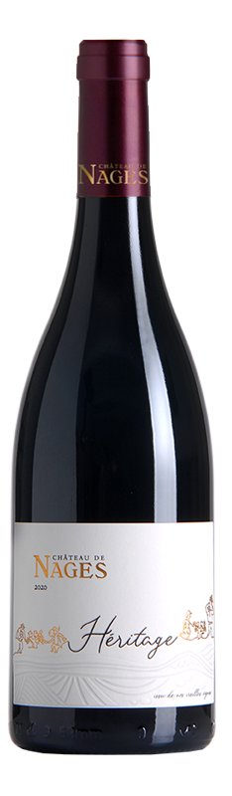
AOP Costières de Nîmes – Certified Organic

Varietals : 60% Grenache, 25% Mourvèdre & 15% Syrah

Vinification :
- certified organic farming with particular attention to soil health
- at veraison, manual pass to remove lateral shoots and “grapillons” (2nd generation grape clusters)
- manual harvest with sorting
- ⅓ whole cluster and ⅔ whole berries without adding SO2
- fermentation with native yeasts at 24°C and a warm maceration (28°C) for 20 days
- aging in French oak of ¼ of the volume and in cement tank for the rest for 12 months

Tasting notes :
- Appearance : brilliant garnet
- Nose : lavish, complex array of ripe red berries (raspberry, cherry), pepper, oriental spices and aromatic herbs
- Taste : rich and balanced with a fine tannic grain, it reveals spices, licorice and minerality in a long elegant finish

Accolades :
89-91 pts – Jeb Dunnuck

Aging potential : enjoy now or cellar for 5 to 8 years.

Food & wine pairing : Serve at 60°F (16°C). Feel free to decant one hour before serving.

cheeses | meats | garden | herbs | method | sauces | desserts
cheddar  ewe’s  munster | lamb  beef  game | mushrooms  lentils  red peppers | thyme  mint  rosemary | stew  roast  grill | red fruit  wine  tomato | chocolate

